# Homework 2

### Problem 1

## i.

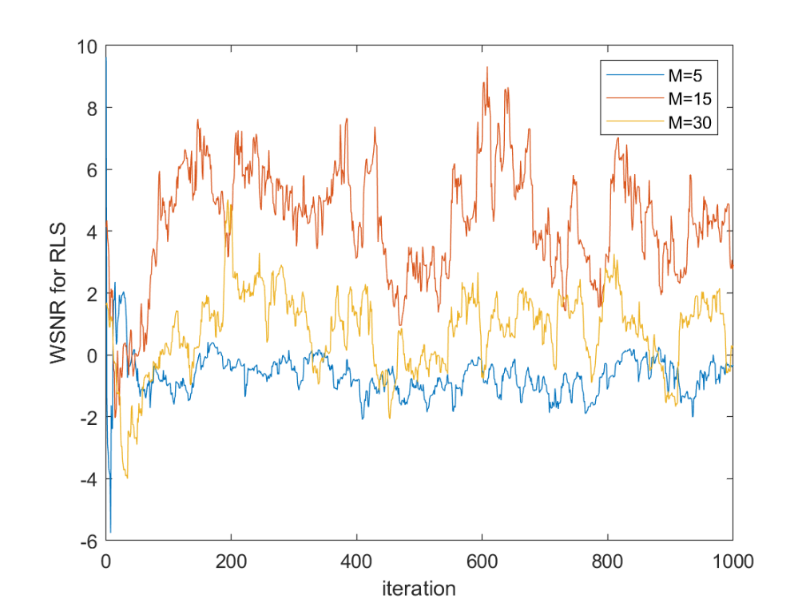

Figure 1. WSNR for RLS with different filter order

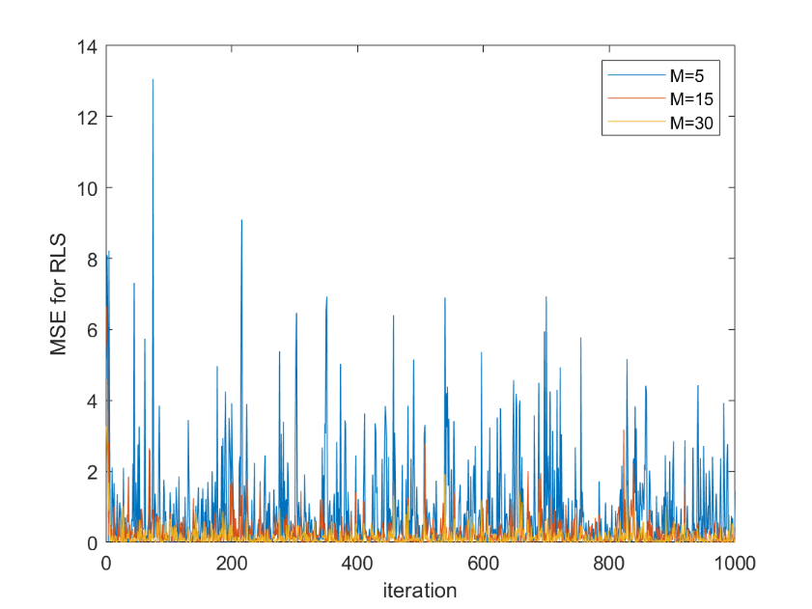

Figure 2. MSE for RLS with different filter order

From Figure 1 & 2, when filter order M =15, WSNR is largest. Meanwhile, filter order 5 has the smallest WSNR and largest MSE. So the best filter order is 15. When M =5, filter order is too small to represent the original system whose M=10. M = 30 is too complex and we do not have enough data to support so complex mode which leads to a lower accuracy. That’s something like overfitting.

## ii.

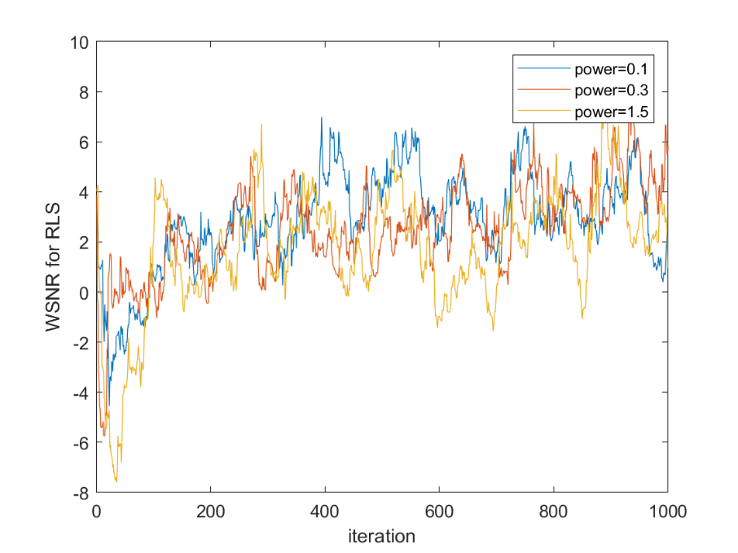

Figure 3. WSNR for RLS with different noise power

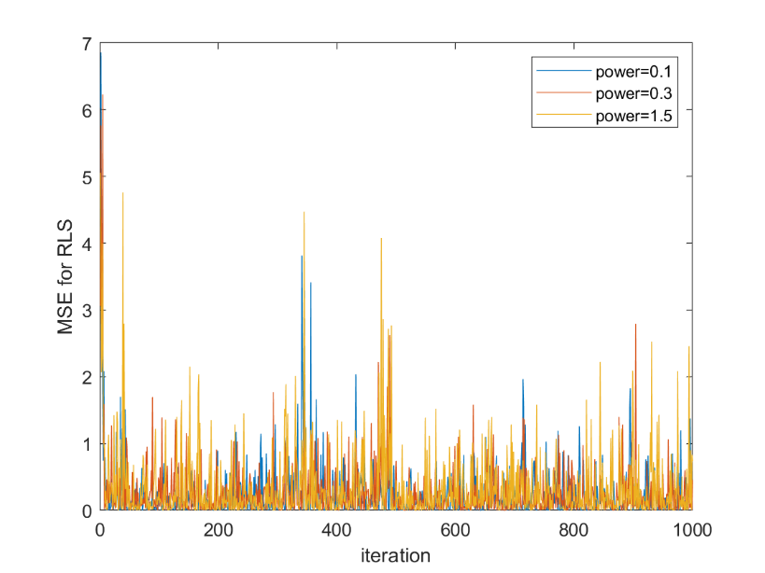

Figure 4. MSE for RLS with different noise power

In fact, I cannot find obvious change in both MSE and WSNR. The change of Gaussian noise does not affect w very much. Gaussian noise will be attenuated through learning.

## iii.

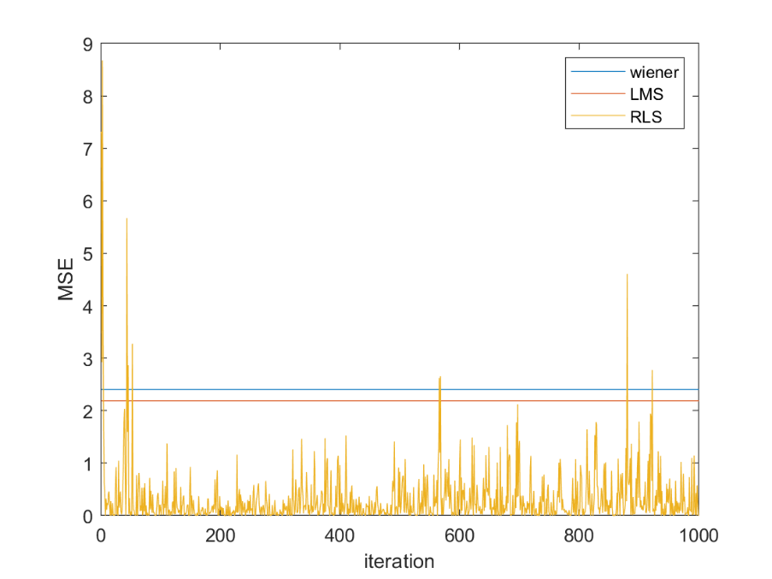

Figure 5. MSE for RLS compared with LMS and wiener solution

To simplify this question, I only use MSE at the end of iteration for LMS and wiener. Basically, RLS has a smaller MSE than LMS and wiener solution. Thus RLS has a better performance.

### Problem 2

## i.

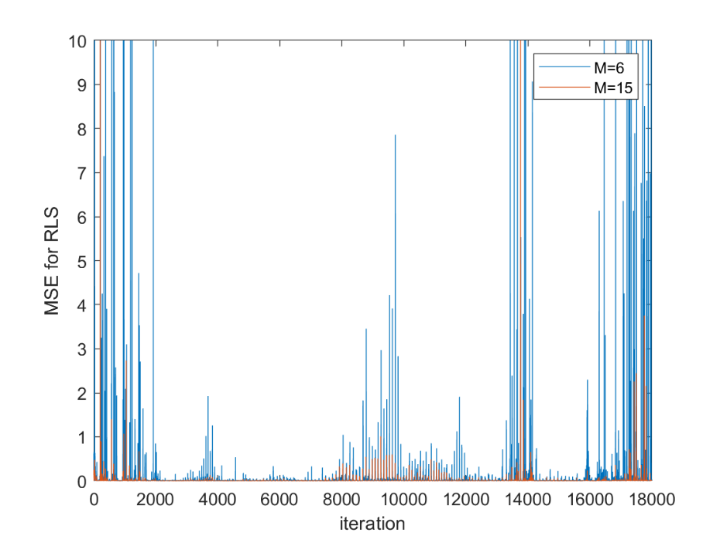

Figure 6 MSE for RLS with different filter order

From Figure 6, M = 15 has the smaller MSE compared with M = 6, so we choose M =15.

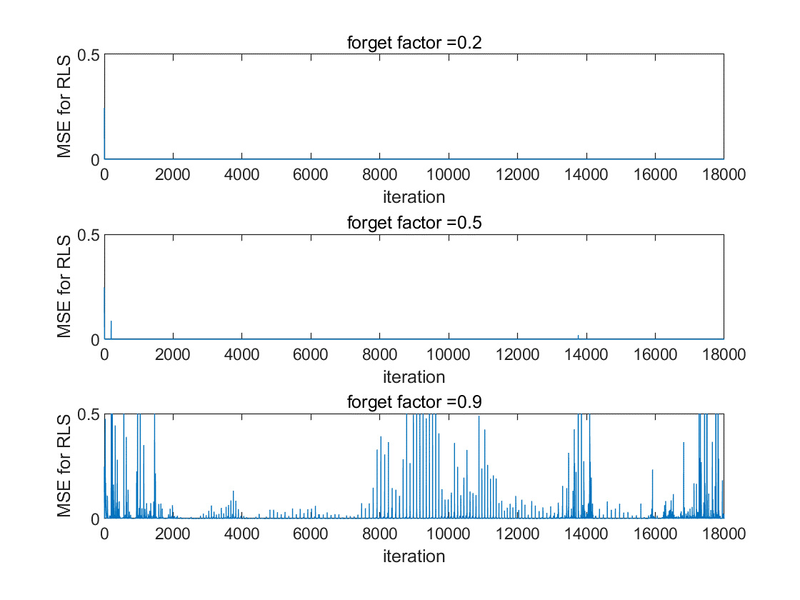

Figure 7. MSE for RLS with different forget factor

Smaller forget factor performs better. I think because the signal is non stationary and changes fast, it’s better to forget former data quickly. So here we can choose a relatively small factor.

## ii.

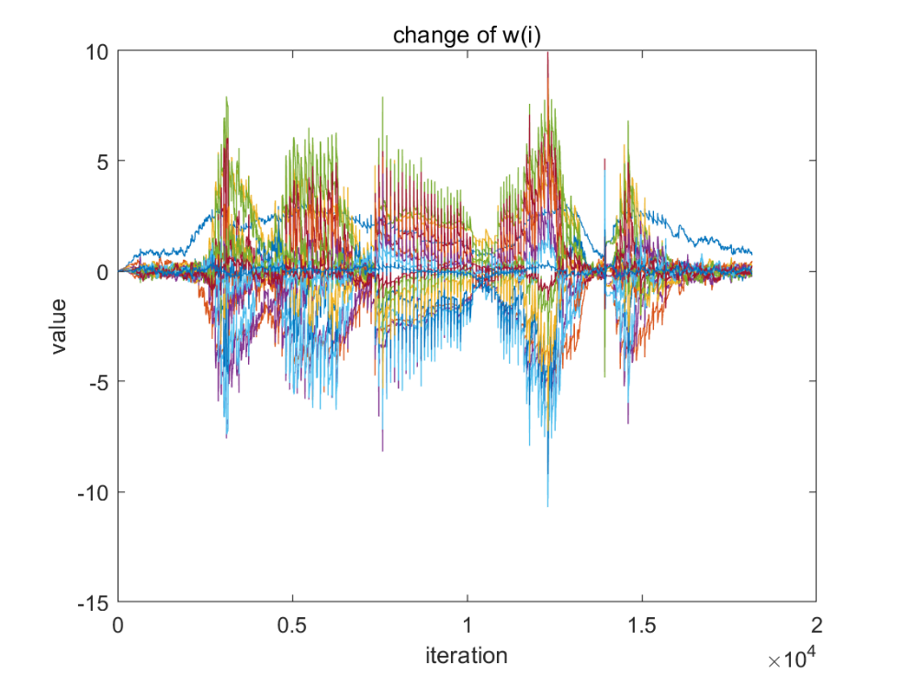

Figure 8. change of filter parameter w

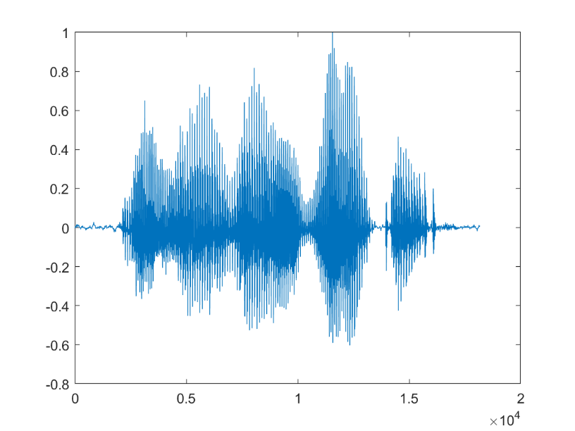

Figure 9. original audio signal

The change of value of parameters is almost synchronous compared to the original speech signal. Parameters are affected not only by present input but also by past input.

## iii.

Maybe it’s better to use a mutative forget factor. They can change forget factor according to the spectrogram. When the signal changes fast, we can use a small forget factor. When the signal is stationary, we can use a large factor even we can use 1 to get a better prediction.

Convergence is important because RLS is a iteration algorithm. If convergence rate is too large, especially large than 1, we will get a bad result because the result is exponential.

## iv.

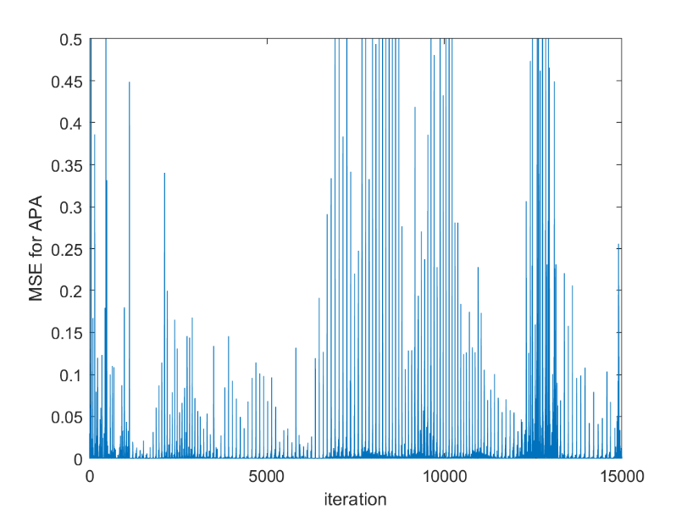

Figure 10. MSE for APA with filter order M = 15

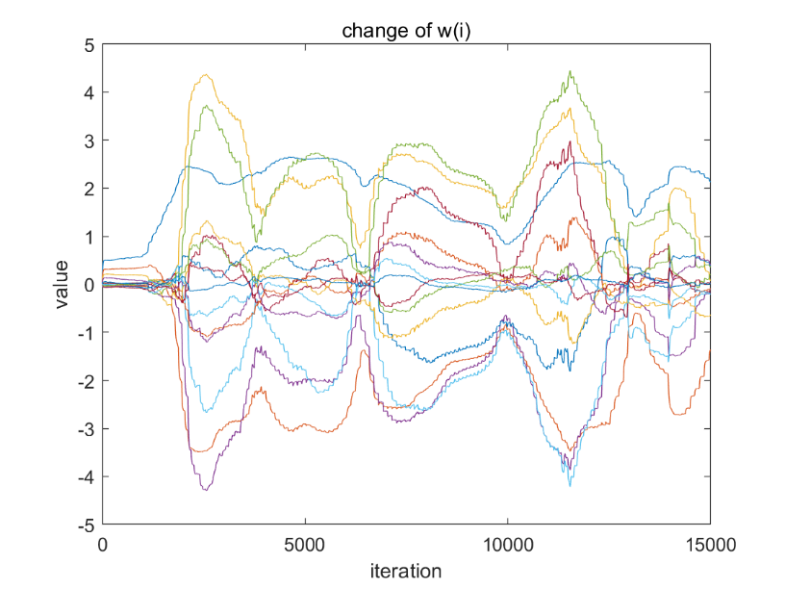

Figure 11. change of filter parameter w with filter order M =15

From Figure 10 & 11, we can find APA’s parameter changes smoothly because here we use several samples. Here I use APA4 because it uses Newton update which can get better result quickly. Besides, it is regularized.

I can’t find obviously different between the result of APA and RLS. Maybe both MSE is too small to find out difference. But APA is more time consuming than RLS.

## v.

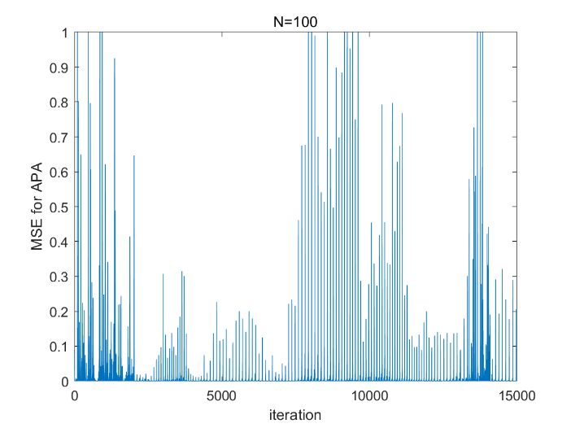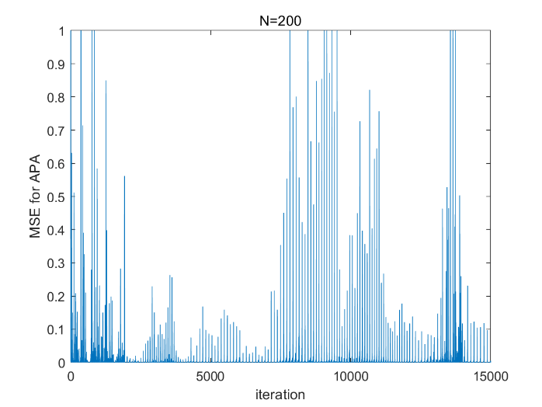

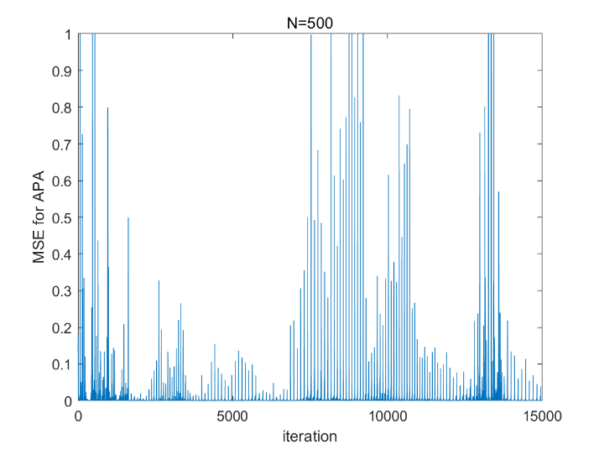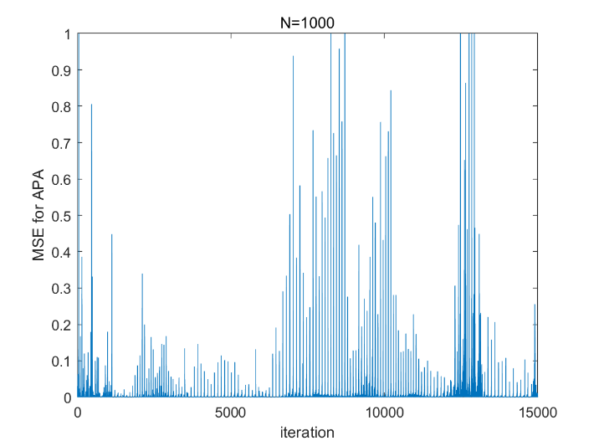

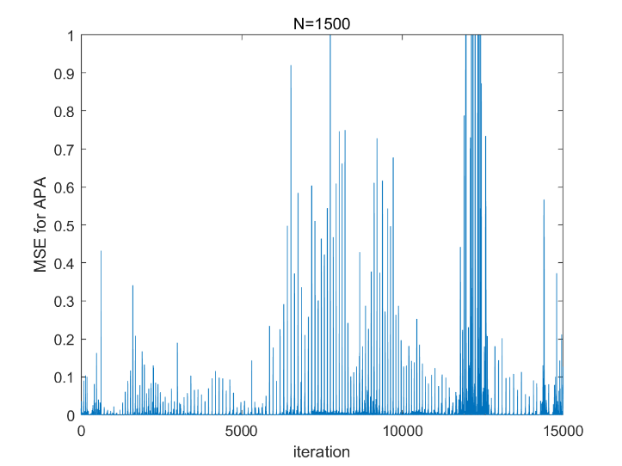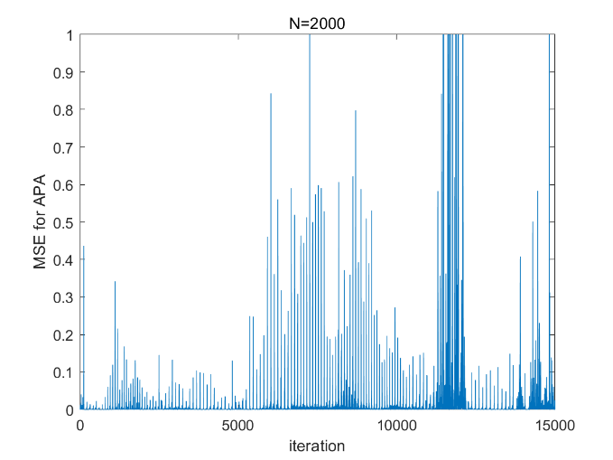

Here I tried 6 different number of samples. When N = 1000, the result is best.

The update equation for APA 4 is 𝐰(𝑖) = (1−𝜂)𝐰 (𝑖 −1) +𝜂𝐔(𝑖)[ 𝐔(𝑖) +𝜆𝐈]^(-1) 𝐝(𝑖)

We assume the number of samples is N, filter order is M, iteration is L.

For each one iteration, the complexity of [ 𝐔(𝑖) +𝜆𝐈]^(-1) is . 𝐔(𝑖)[ 𝐔(𝑖) +𝜆𝐈]^(-1) is  𝜂𝐔(𝑖)[ 𝐔(𝑖) +𝜆𝐈]^(-1) 𝐝(𝑖) is .

So the entire complexity is about ). So it is .